**Practical-9**

**Aim:-** Create a windows Form for Hotel Menu using ListView.

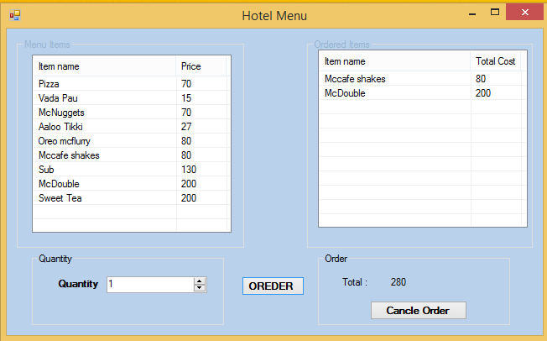

The form should contain ListView, NumericUpDpwn and button as displayed.

You should be able to select single item from listview.

The selected values can be shifted in another listview displayed.

The selected multiple items can be removed from listview 2.

Make total of selected item in display in label.

**Code:**

**Form1.cs**

using System;

using System.Collections.Generic;

using System.ComponentModel;

using System.Data;

using System.Drawing;

using System.Linq;

using System.Text;

using System.Threading.Tasks;

using System.Windows.Forms;

namespace Practical_9

{

public partial class Form1 : Form

{

static int total = 0;

public Form1()

{

InitializeComponent();

}

private void Form1_Load(object sender, EventArgs e)

{

listView1.Columns.Add("Iteam Menu", 174);

listView1.Columns.Add("Price");

listView1.View = View.Details;

addtolistview("Pizza", 70);

addtolistview("Dabeli", 20);

addtolistview("Puff", 15);

addtolistview("Sandwich", 80);

addtolistview("Burger", 50);

addtolistview("aaloo tikki", 45);

addtolistview("McDouble", 200);

addtolistview("Bhel", 20);

addtolistview("Cold Drik", 150);

addtolistview("Ice Cream", 100);

addtolistview("Water", 35);

numericUpDown1.Minimum = 1;

numericUpDown1.Maximum = 20;

listView1.FullRowSelect = true;

listView2.Columns.Add("Item", 90);

listView2.Columns.Add("Quantity", 50);

listView2.Columns.Add("Price");

listView2.View = View.Details;

}

private void addtolistview(string ins, int price)

{

ListViewItem l = new ListViewItem(ins,price);

l.SubItems.Add(price.ToString());

listView1.Items.Add(l);

}

private void button1_Click(object sender, EventArgs e)

{

if (listView1.SelectedItems.Count > 0)

{

ListViewItem item = new ListViewItem(listView1.SelectedItems[0].Text);

int pr = Convert.ToInt32(listView1.SelectedItems[0].SubItems[1].Text);

pr =pr* Convert.ToInt32(numericUpDown1.Value);

item.SubItems.Add(numericUpDown1.Value.ToString());

item.SubItems.Add(pr.ToString());

listView2.Items.Add(item);

total = total + pr;

label3.Text = total.ToString();

}

else

{

MessageBox.Show("Please Selected one iteams");

}

}

private void button2_Click(object sender, EventArgs e)

{

if (listView2.SelectedItems.Count > 0)

{

DialogResult confirm = MessageBox.Show("item is cancel");

for (int i = listView2.SelectedItems.Count -1; i>=0;i--)

{

int pr = Convert.ToInt32(listView2.SelectedItems[i].SubItems[2].Text);

total = total - pr;

label3.Text = total.ToString();

listView2.SelectedItems[i].Remove();

}

}

else

{

MessageBox.Show("Please Select at least one iteam");

}

}

}

}

**Output:**



